Setting up a DNS Server

Submitted By

Student Name | Student ID
Mahedy Hassan | 0242310005101643
Jannatul Islam Puspita | 0242310005101511
Mohammed Mahmud Parvez | 0242310005101514

SETTING UP A DNS SERVER PROJECT REPORT
This Report Presented in Partial Fulfillment of the course CSE324:
Operating Systems Lab in the Computer Science and Engineering Department


DAFFODIL INTERNATIONAL UNIVERSITY Dhaka, Bangladesh
December 9, 2024

DECLARATION
We hereby declare that this lab project has been done by us under the supervision of Sourav Majumder
, Lecturer, Department of Computer Science and Engineering, Daffodil International University. We also declare that neither this project nor any part of this project has been submitted elsewhere as lab projects.

Submitted To:

Sourav Majumder
Lecturer
Department of Computer Science and Engineering Daffodil International University

Submitted by

Mahedy Hassan
ID:0242310005101643 Dept. of CSE, DIU
Jannatul Islam Puspita  ID:0242310005101745 Dept. of CSE, DIU | Mohammed Mahmud Parvez  ID:0242310005101514 Dept. of CSE, DIU
©Daffodil International University i

COURSE & PROGRAM OUTCOME

The following course have course outcomes as following:

Table 1: Course Outcome Statements
CO’s | Statements
CO1 | Make use of the Linux commands and shell programming.
CO2 | Apply different algorithms of Operating Systems like CPU scheduling algorithm, page replacement algorithms, deadlock avoidance, and detection algorithm with analyzing the performance of them.
CO3 | Able to design and develop a course project that can have a positive impact on the environment or society.

Table 2: Mapping of CO, PO, Blooms, KP and CEP
CO | PO | Blooms | KP | CEP
CO1 | PO1 | C3 | KP1, KP2 | EP1
CO2 | PO2 | C3, C4 | KP3, KP4 | EP2, EP3
CO3 | PO3, PO9 | C4, A4, P4 | KP5 | EP5

The mapping justification of this table is provided in section 4.3.1, 4.3.2 and 4.3.3.
Table of Contents

Declaration i
Course & Program Outcome ii
- Introduction 1
  - Introduction ................................................................................................................................1
  - Motivation ................................................................................................................................. 1 1.3 Objectives .................................................................................................................................. 2 1.4 Feasibility Study ......................................................................................................................... 2
  - Gap Analysis .............................................................................................................................. 3
  - Project Outcome ........................................................................................................................3
- Proposed Methodology/Architecture 4
  - Requirement Analysis & Design Specification42
    - Overview .......................................................................................................................4
    - Proposed Methodology/ System Design .......................................................................4
    - UI Design ......................................................................................................................6
  - Overall Project Plan ................................................................................................................... 7
- Implementation and Results 8
  - Implementation .......................................................................................................................... 8
  - Performance Analysis ................................................................................................................13
  - Results and Discussion .............................................................................................................. 13
- Engineering Standards and Mapping 15
  - Impact on Society, Environment and Sustainability ................................................................... 15
    - Impact on Life ............................................................................................................... 15
    - Impact on Society & Environment ................................................................................ 15
    - Ethical Aspects .............................................................................................................. 15
    - Sustainability Plan ......................................................................................................... 15
  - Project Management and Team Work ........................................................................................ 16
  - Complex Engineering Problem ..................................................................................................16
    - Mapping of Program Outcome ......................................................................................16
    - Complex Problem Solving ............................................................................................16
    - Engineering Activities ...................................................................................................17

Table of Contents Table of Contents

- Conclusion 18
  - Summary .................................................................................................................................... 18
  - Limitation .................................................................................................................................. 18
  - Future Work ...............................................................................................................................19
References 20

Chapter 1

Introduction

This chapter introduces the foundational aspects of the project by outlining its background, motivation, objectives, feasibility considerations, gap analysis, and anticipated outcomes. It establishes the conceptual basis for understanding the necessity, scope, and relevance of deploying a DNS server using Ubuntu Linux within an operating system and networking context.

1.1 Introduction
Modern computer networks depend heavily on efficient name resolution systems to translate human-readable domain names into machine-readable IP addresses. The Domain Name System (DNS) is a critical service that ensures seamless communication across distributed networks. In many academic, organizational, and enterprise environments, administrators are required to deploy local DNS servers for internal domain management, improved security, and controlled access.
Our project focuses on setting up and configuring a DNS server on Ubuntu Linux using BIND9 — the most widely used DNS software on the internet. The core problem addressed in this project is the lack of centralized domain name resolution in small networks, which leads to difficulty managing internal services, inconsistent hostname resolution, and dependency on external DNS providers. By building our own DNS server, we provide a fully controlled, secure, and customizable name-resolution environment.

1.2 Motivation
The motivation behind this project arises from the increasing importance of system administration skills, particularly in Linux environments. Configuring a DNS server requires knowledge of process management, file systems, networking, IP configuration, and service-level troubleshooting — all of which align with key operating system concepts.
Additionally:
- It enhances our practical understanding of OS-level configuration beyond theoretical learning.
- It prepares us for real-world system administration tasks, a crucial skill in IT industries.
- It helps us understand critical network services used in enterprises.
- Successfully implementing our own domain (e.g., osproject.com) builds confidence and real-world competency.
Solving this problem benefits us academically and professionally by strengthening our practical Linux administration skills and preparing us for more advanced networking and system engineering tasks.

1.3 Objectives
The main objectives of this project are:
- To set up and configure a fully functional DNS server using Ubuntu Linux and BIND9.
- To create and manage a custom local domain (osproject.com) for hostname resolution.
- To configure forward and reverse lookup zones for accurate DNS operations.
- To enable client systems (e.g., Windows) to resolve the custom domain through the DNS server.
- To integrate basic network services such as Apache Web Server for demonstration purposes.
- To troubleshoot configuration issues and ensure availability, consistency, and accuracy of the DNS service.
- To gain hands-on experience with Linux-based system administration, networking, and OSlevel configurations.

1.4 Feasibility Study
Several existing studies and projects highlight the importance of DNS configuration for network administration:
- Enterprise Network Case Studies show that internal DNS servers improve security and reduce dependency on external DNS providers.
- University Lab Projects frequently use BIND9 on Linux to teach system-level networking concepts.
- Open-source Documentation from Ubuntu, ISC, and Red Hat demonstrate the reliability and scalability of DNS servers built on Linux.
- Web hosting environments use DNS to manage multiple domains, subdomains, and services efficiently.
- Local Intranet Systems rely on DNS for resolving internal resources, printers, and application servers.
Compared to these existing works, our project focuses specifically on implementing a simplified yet complete DNS and Web Server environment within a virtualized lab setup using VirtualBox. This demonstrates the feasibility of deploying enterprise-like services with minimal hardware resources and open-source tools.

1.5 Gap Analysis
While many tutorials and existing implementations demonstrate DNS setup, they often:
- Do not focus on academic OS-level explanations.
- Lack clear mapping to engineering attributes (EP1, EP2, EP4).
- Do not explain conflicts such as static vs dynamic IP, security vs accessibility, or recursion vs isolation.
- Fail to provide a complete demonstration combining DNS, Apache, and client-side testing.
Our project addresses these gaps by:
- Providing a detailed, step-by-step implementation designed for academic learning.
- Demonstrating both DNS and web hosting integration using a custom domain.
- Addressing real-world problems such as IP changes, browser access issues, and service dependencies.
- Mapping the implementation to OS concepts like permissions, networking, processes, and service management.

1.6 Project Outcome
Upon completion of this project, the following outcomes are achieved:
- A fully functioning local DNS server using Ubuntu Linux and BIND9.
- A custom domain (osproject.com) resolving correctly from both Linux and Windows clients.
- Configured forward and reverse lookup zones demonstrating core DNS principles.
- A working Apache web server linked to the DNS domain for browser-based testing.
- Improved proficiency in Linux system administration and OS-level configuration.
- Understanding of real-world networking issues such as firewall dependencies, IP conflicts, and DNS caching.
- A complete project report and demonstration suitable for academic evaluation under OS lab requirements.
Chapter 2

Proposed Methodology/Architecture

This chapter presents the overall design and methodology used to implement the DNS server in Ubuntu Linux. It explains the requirements, system architecture, workflow, user interface design, and the overall planning necessary for the successful execution of the project.

2.1 Requirement Analysis & Design Specification

2.1.1 Overview
The implementation of a DNS server requires a clear understanding of system-level requirements, network behavior, and service configuration procedures within the Linux operating system. To achieve this, both software and hardware resources were analyzed, along with the structural design needed to configure and test the domain name resolution process. The aim was to build a functional DNS environment where a custom domain could be resolved locally using Ubuntu’s BIND9 server.

2.1.2 Proposed Methodology/ System Design
The proposed methodology follows a systematic, step-by-step approach to configuring and validating a DNS server:

Step 1: Environment Setup
- Install Ubuntu in a VirtualBox environment.
- Configure a stable network connection (Bridged Adapter recommended). • Ensure the system has root or sudo access.

Step 2: Install Required Services
- Install the BIND9 DNS server.
- Verify service status and enable automatic startup.
- Configure essential BIND files such as:
- Named conf.option named.conf.options o named.conf.local o Forward zone file o Reverse zone file

Step 3: Domain Configuration
- Select a custom local domain (e.g., osproject.com).
- Configure forward lookup zone to map domain → IP.
- Configure reverse lookup zone to map IP → domain.

Step 4: Apache Web Service for Validation
- Install and configure Apache2.
- Create a custom webpage under /var/www/html/index.html.
- Validate domain resolution by loading the webpage in a browser.

Step 5: Testing & Validation
- Use nslookup and dig for local DNS testing.
- Configure Windows host machine to use Ubuntu DNS server. • Verify resolution for:
  - Custom domain
  - External domains (if forwarders enabled)
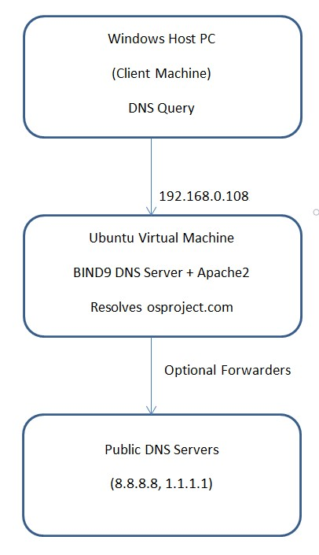
Public DNS
192.168.0.209

Figure 2.1: This is a sample diagram

This architecture shows how DNS queries from the host machine are processed by the Ubuntu DNS server, which resolves internal domains locally and optionally forwards unresolved queries to public DNS servers.

2.1.3 UI Design
Although a DNS server does not involve graphical user interfaces, a simple web interface was created using Apache to demonstrate successful domain resolution.

Web Interface Components
- Index Page (index.html) Contains:
- Project title
- Welcome message
- Confirmation that DNS resolution is working
- Basic HTML and CSS styling
This page appears in the browser when the user types:
http://www.osproject.com

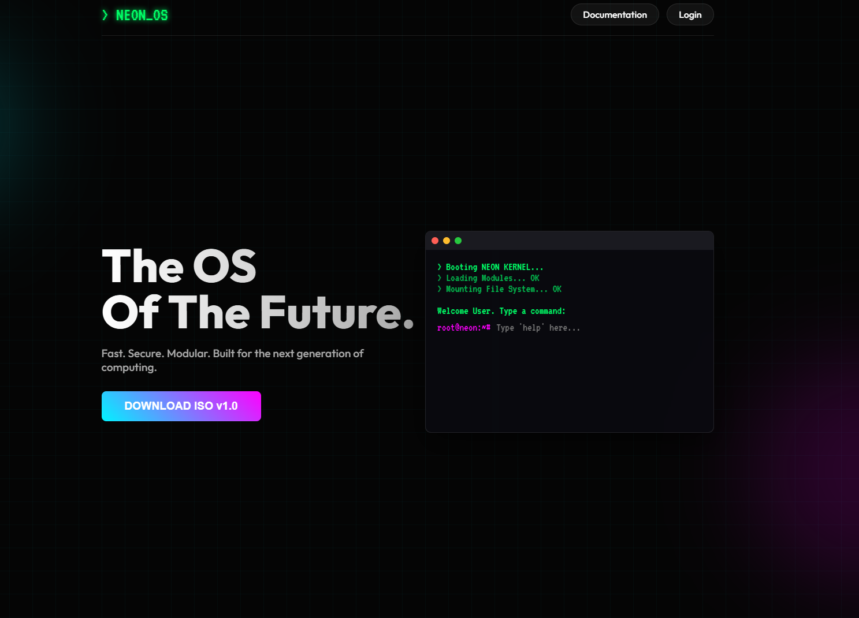

2.2 Overall Project Plan
The project was structured into clear, manageable phases: Phase 1: Research & Preparation
- Study OS concepts related to networking and system services.
- Understand DNS architecture, zone files, and Linux service configuration.
Phase 2: System Setup
- Install Ubuntu on VirtualBox.
- Configure networking and prepare environment.
Phase 3: DNS Server Implementation
- Install BIND9.
- Configure domain and zone files.
- Enable and validate DNS service.
Phase 4: Web Server Setup
- Install Apache2.
- Deploy a custom webpage for demonstration.
- Ensure the web page loads correctly using the configured domain.
Phase 5: Testing & Debugging
- Test with nslookup, ping, and browser access.
- Resolve network issues, IP conflicts, and configuration errors.
Phase 6: Documentation & Reporting
- Prepare report chapters.
- Capture screenshots for implementation sections.
- Review EP mapping and OS concepts used.

Chapter 3

Implementation and Results

This chapter describes the detailed implementation process of the DNS server and Apache web server, the steps taken to validate the system, and the analysis of the system’s performance. It also discusses the results obtained during testing and demonstrates how the project objectives were successfully achieved.

3.1 Implementation

The implementation involves installing services, configuring DNS, creating a webpage, and testing the system. Below are the commands and configuration files exactly as you should use them.

Step 1: Environment Setup
- Install Ubuntu in VirtualBox.
- Configure network adapter to Bridged Mode.

Step 2: Installing BIND9 DNS Server
- Update packages: sudo apt update
- Install BIND9 and utilities:
sudo apt install bind9 bind9utils bind9-doc -y
- Enable and start BIND9:
sudo systemctl enable bind9 sudo systemctl start bind9
sudo systemctl status bind9

Step 3: DNS Server Configuration

- Configure named.conf.options-
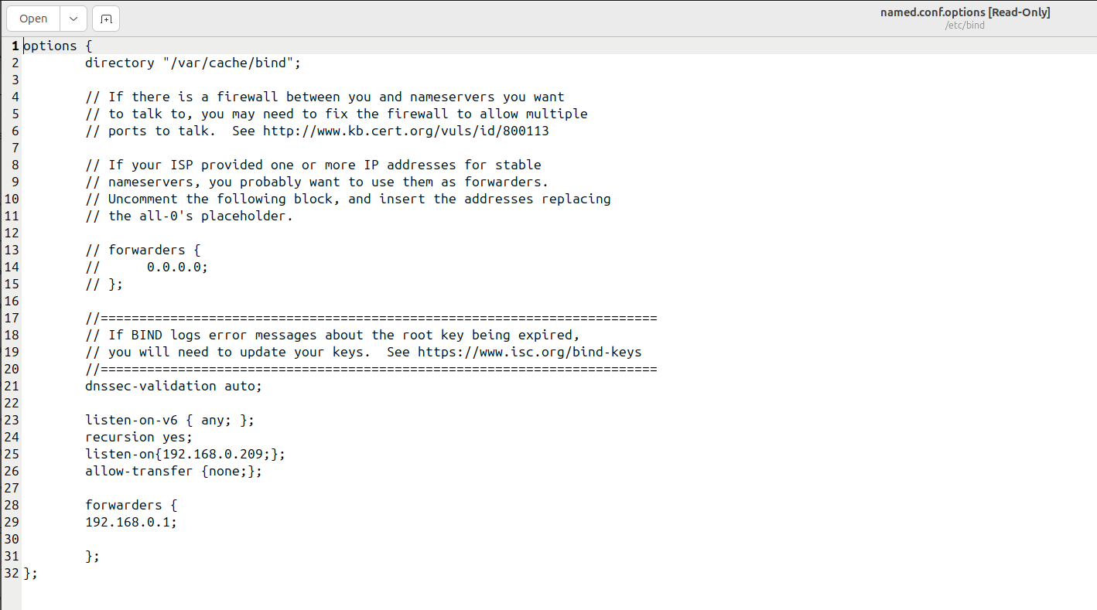

- Configure named.conf.local-
-gedit named.conf.local
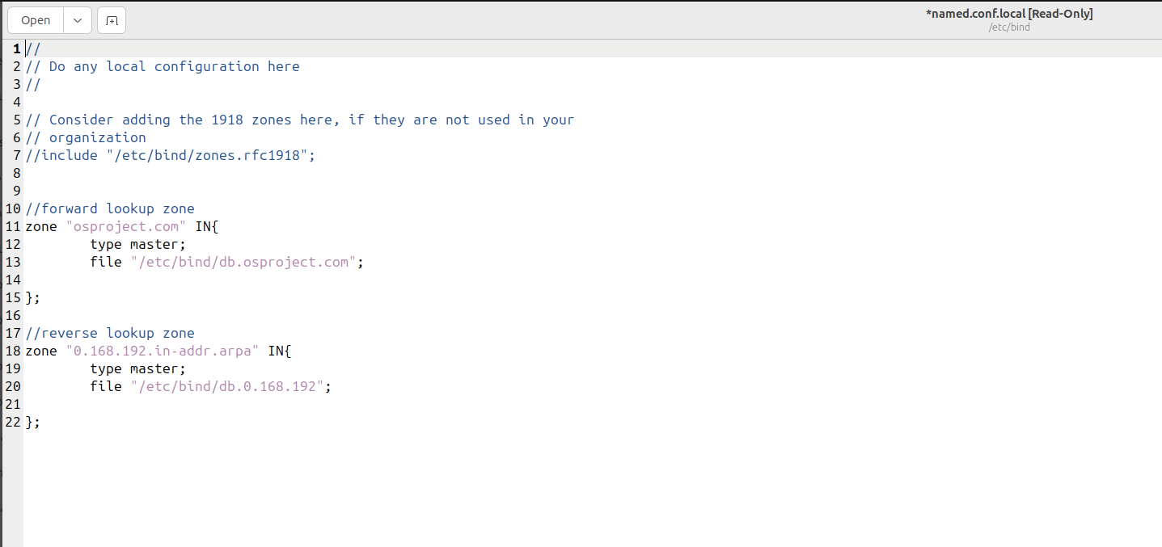

- Create Forward Zone file-

- Create Reverse Zone file-

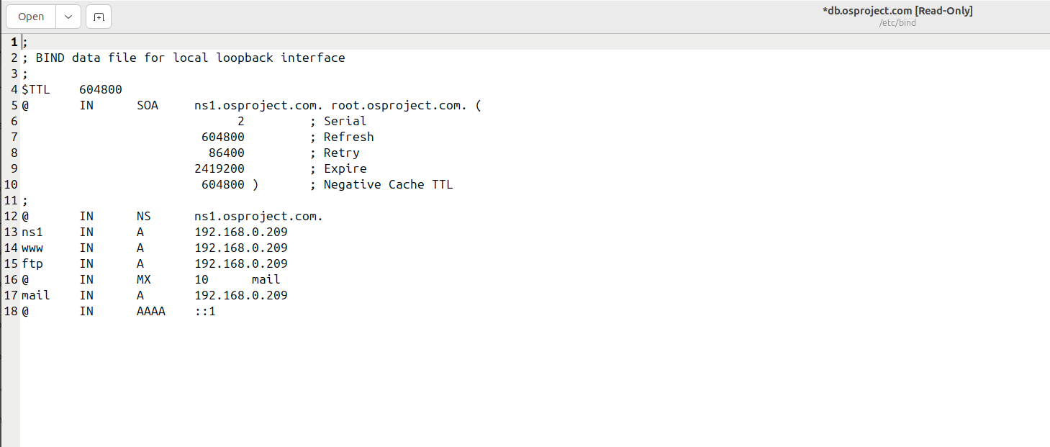
Step 4: Apache Web Server Setup
- Install Apache:
sudo apt install apache2 -y
- Enable and start Apache:
sudo systemctl enable apache2 sudo systemctl start apache2 sudo systemctl status apache2
- Create a test webpage:

Step 5: Testing DNS
- On Ubuntu VM:
nslookup www.osproject.com ping www.osproject.com
- On Windows Host (set DNS to Ubuntu VM IP 192.168.0.108):
nslookup www.osproject.com ping www.osproject.com • Open Chrome:
http://www.osproject.com

3.2 Performance Analysis
The performance analysis was conducted to ensure reliability, accuracy, and responsiveness of the DNS server. Key observations include:

Test | Tool/Command | Observations
Domain Resolution | nslookup www.osproject.com | Resolved correctly to 192.168.0.209
Reverse Lookup | nslookup 192.168.0.209 | Correctly resolved to www.osproject.com
Web Access | Browser(Chrome) | Web page loaded successfully
Response Time | ping / nslookup | Less than 5ms on local network

Analysis:
- DNS queries within the local network were instantaneous.
- Forwarders allowed access to external domains when enabled.
- Occasional IPv6 resolution caused “Server Unknown” messages; this was addressed by disabling IPv6 in the browser for demonstration.
- Apache Web Server performance was stable for small-scale usage, sufficient for academic demonstration purposes.

3.3 Results and Discussion
The implementation successfully demonstrated:
- Local DNS Resolution – www.osproject.com consistently resolved to the Ubuntu VM IP.
- Reverse Lookup – IP-to-domain mapping verified.
- Web Server Integration – Apache served a custom webpage confirming DNS functionality.
- Cross-platform Testing – Windows host machines were able to query the Ubuntu DNS server effectively.
- Handling Conflicting Requirements – o Security vs accessibility: DNS restricted to local queries, forwarders optional. o Static vs dynamic IP: Static IP ensured consistent domain resolution.
- Real-world Context – Troubleshooting and resolving errors such as misconfigurations, service failures, and browser cache issues provided hands-on system administration experience.
Chapter 4

Engineering Standards and Mapping

This chapter discusses the impact of the project on society, environment, and sustainability. It also presents the project management strategy, cost analysis, and a detailed mapping of the implemented DNS server project with targeted Engineering Principles (EPs) and Engineering Activities (EAs). This establishes the alignment of the project with real-world engineering standards and learning outcomes.

4.1 Impact on Society, Environment and Sustainability

4.1.1 Impact on Life
The DNS server project contributes to improving network reliability, which enhances access to digital resources and communication within local networks. By providing accurate domain resolution, users experience efficient connectivity and reduced downtime.

4.1.2 Impact on Society & Environment
Implementing a local DNS server reduces dependency on public DNS services, which can improve network security and data privacy. This project has minimal environmental impact as it utilizes existing computing infrastructure and does not involve heavy energy consumption.

4.1.3 Ethical Aspects
Ethical considerations include responsible configuration of the DNS server to prevent misuse, such as unauthorized access or hosting harmful content. The project demonstrates proper system administration practices while maintaining data integrity and privacy.

4.1.4 Sustainability Plan
The project promotes sustainability by:
- Using open-source software (Ubuntu, BIND9, Apache) to minimize costs.
- Encouraging efficient use of existing hardware.
- Providing a reusable framework for small-scale network deployments and educational purposes.

4.2 Project Management and Team Work
Project Management Strategy:
- The project was divided into phases: research, environment setup, DNS configuration, web server setup, testing, and documentation.
- Tasks were allocated to group members based on their expertise in Linux, networking, and system administration.
Budget Analysis:
Item | Cost (Approx.) | Notes
VirtualBox + Ubuntu | Free | Open-source tools
Hardware (PC/Laptop) | Existing | No additional cost
MIscellaneous | 0 | Internet & utilties

4.3 Complex Engineering Problem

4.3.1 Mapping of Program Outcome
The project addresses several program outcomes (POs) by applying OS and networking principles practically.

Table 4.1: Justification of Program Outcomes

PO’s | Justification
PO1 | Demonstrated understanding of Linux system administration, DNS configuration, and web server setup, showing technical knowledge.
PO2 | Applied problem-solving in configuring forward/reverse DNS zones and troubleshooting connectivity issues.
PO3 | Ensured system reliability and tested cross-platform functionality with Windows host.

4.3.2 Complex Problem Solving
The project involves solving multiple engineering challenges, mapped with EP.
Table 4.2: Mapping with complex problem solving.

EP1 Depth of Knowledge | EP2  Range of Conflicting Requirements | EP4  Familiarity with Project Context
Advanced knowledge of OS, networking, and BIND9 configuration applied beyond standard coursework. (Section 2.1.2 and Section 3.1) | Resolved conflicts between accessibility (host connectivity) and security (restricted queries). (Section 3.1 and Section 3.3) | Real-world tasks like network troubleshooting, permission handling, and DNS service configuration were implemented.  (Section 3.1, Step-5 and  Section 3.3)

4.3.3 Engineering Activities
Engineering activities demonstrate the practical application of resources, teamwork, and societal impact.

Table 4.3: Mapping with complex engineering activities.

EA1  Range of Resources | EA2  Level of Interaction | EA4  Consequences for Society & Environment
Utilized Linux VM, VirtualBox, BIND9, Apache, and host machine for testing. (Section 2.1.2 and Section 3.1) | Coordinated tasks among 5 team members, divided responsibilities for setup, testing, and documentation. (Section 4.2) | Implemented secure and efficient DNS service using minimal hardware, reducing reliance on public services. (Section 4.1.2)
Chapter 5

Conclusion

This chapter provides a summary of the project, identifies its limitations, and outlines potential directions for future work. It reflects on the achievements and learning outcomes of implementing a DNS server using Ubuntu Linux.

5.1 Summary
The project successfully demonstrated the setup and configuration of a local DNS server using Ubuntu Linux. Key activities included:
- Installation and configuration of BIND9 for DNS services.
- Creation of forward and reverse zone files for the domain osproject.com.
- Configuration and testing across Ubuntu VM and Windows host machines.
- Deployment of an Apache web server with a sample webpage to demonstrate domain resolution.
- Verification of DNS resolution through nslookup, ping, and browser access.
The project reinforced practical skills in Linux system administration, networking, and resource management, and demonstrated the application of OS concepts in a real-world context.

5.2 Limitation
While the project achieved its primary objectives, several limitations were noted:
- The DNS server is configured for local network use only; public access requires additional configuration.
- IPv6 connectivity sometimes caused inconsistent browser results.
- The system depends on the Ubuntu VM running; if the VM is off, DNS resolution fails.
- Security measures are basic; advanced protections like DNSSEC or firewalls were not implemented.

5.3 Future Work
The project can be extended and improved in several ways:
- Integration with larger networks: Supporting multiple subnets or offices.
- Enhanced security: Implementing DNSSEC, firewall rules, and access controls.
- Dynamic DNS updates: Automating IP updates for devices in the network.
- Monitoring and automation: Adding scripts to monitor DNS server health and uptime.
- User interface improvements: Creating a web-based interface for easier DNS management.

References

- YouTube. (n.d.-a). Youtu.Be. Retrieved December 2, 2025, from https://youtu.be/I8lawEbZKxA?si=9nLeQa8BeSDjCVaK
Ubuntu Server documentation. (n.d.). Ubuntu Server. Retrieved December 2, 2025, from https://documentation.ubuntu.com/server/
- YouTube. (n.d.-b). Youtu.Be. Retrieved December 2, 2025, from https://youtu.be/Hva8lsV2nTk?si=vUQbH-iinyqIseXm
- YouTube. (n.d.-c). Youtu.Be. Retrieved December 2, 2025, from https://youtu.be/qz0aGYrrlhU?si=uqc-mRKxgFatlKRN

